**Project Name:** Crop Prediction

**Github Link:** https://github.com/projectsforstudents2022/Crop_Prediction.git

**Why was this project created?**

India has an agriculture-based economy, and farming accounts for the lion's share of its GDP. This initiative was inspired by the rising suicide rates among farmers, which may be related to poor crop yields. The field of agriculture is now seriously threatened by changes in the climate and other environmental factors. For this problem to be solved effectively and practically, machine learning is a crucial strategy. estimating agricultural output based on historical information such weather, soil, rainfall characteristics, and previous crop yield. Utilizing a machine learning method, we were successful.

**What problem is it solving?**

The project's objective is to assist users in selecting the best crop to produce in order to maximize output and, consequently, profit. The approach we suggest is to create a system that takes into account the factors that have the greatest influence on how well a crop grows and to increase the variety of crops that may be cultivated throughout the season. This would make it easier for farmers to choose crops that will provide a high yield and optimize revenues.

**Entire explanation of project**

* **PROPOSED APPROACH**

The system's implementation can be split into frontend and backend implementations. The ionic development tools are used to implement the frontend. Ionic Framework is an open source UI toolkit with integrations for well-known frameworks like Angular and React for creating high-performance, high-quality mobile and desktop apps. Ionic Framework focuses on the UI controls, interactions, gestures, and animations of the frontend UX of an app. As a result, it may be used on any platform. It interfaces with other libraries or frameworks, such as Angular and React.

With just one code base, the system can be developed and deployed across a variety of platforms, including native iOS, Android, desktop, and the web as a Progressive Web App. With the aid of Ionic, the fundamental elements may be made to function independently in a web page using only a script tag. Firebase hosts the data that is required for the system or resources. Regardless of network quality, Firebase Storage offers secure file uploads and downloads for Firebase apps to be used for storing photos, audio, video, and other user-generated information. Firebase supports all file types, including CSS, HTML, JavaScript, and others. System performance is improved.

* **RESULT**

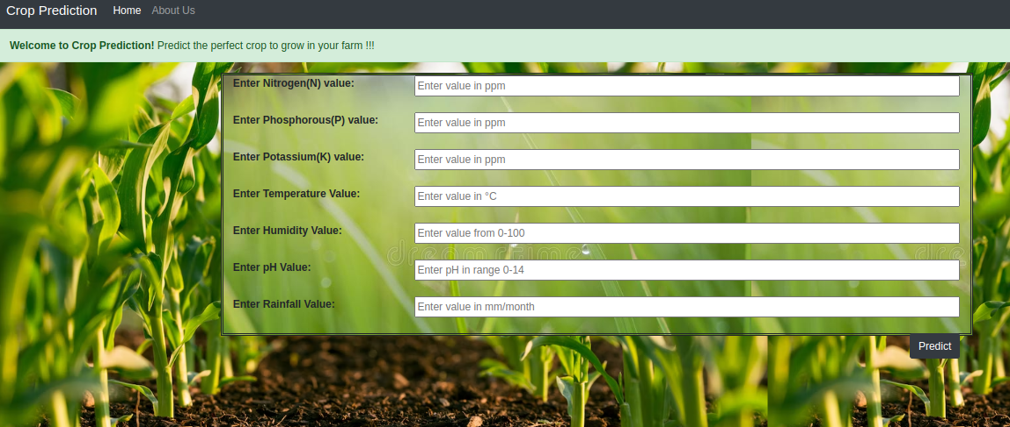

**CONCLUSION**

The Crop Recommender system aids farmers in making decisions regarding which crop to cultivate as well as yield predictions for certain crops. Additionally, it instructs the user when to apply the fertilizer. Machine learning tools were used to gather, analyze, and train relevant datasets. Only a few details, such as the soil type and location, are required from the user. This system benefits the agricultural industry. One of the system's most significant and original contributions is proposing to the user when to apply fertilizer; this is accomplished by forecasting the weather for the following 14 days. According to the meteorological circumstances, the system generates a list of crops and their productions.